Tetrahedron Kite Lab Worksheet

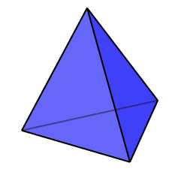
What is a tetrahedron?

- It has _______ faces
- Each face is a _____________________________
- It has ______ Edges
- It has ______ Vertices
- At each vertex ______ edges meet

Find the total surface area of the tissue paper on your kite.

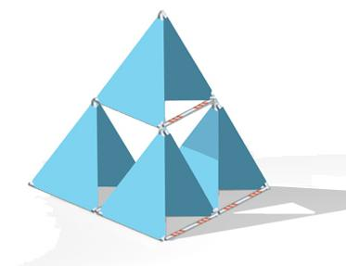
Stage 1:

Stage 2:

Stage | Number of Tetrahedrons (n)
1
2
3
4
5
10

Taking it Further

Look at the chart on the previous page, what kind of patterns do you see? Find a formula to predict the 100th stage.

Reflection

What went well? How could we have improved the kites?

